**Question – 4**

**ONLINE FOOD DELIVERY SYSTEM**

**FILES USED:**

* index.html
* style.css
* phone.css

**index.html:**

As we know HTML code describes the structure of the webpage. So, firstly it has an header tag to display the name of the company which is “MyOnlineMeal”. The navigation bar contains tab of “Home”, “Service”, “Our Clients” and “Contact Us”. The navigation bar also consists of the logo of the company followed by the background image with some more details about the “MyOnilineMeal” along with the featured services.

**style.css:**

This is the stylesheet block which gives us the proper look of webpage.

* Header Styling - I have used font-style to style the header and also used some colors to make it look attractive.
* Navigation Bar Styling - I have used it for logo designing and content designing.
* Background Image Styling – I used before pseudo selectors to set the respective background images.

**OUTPUT-**

**15 inch laptop-**

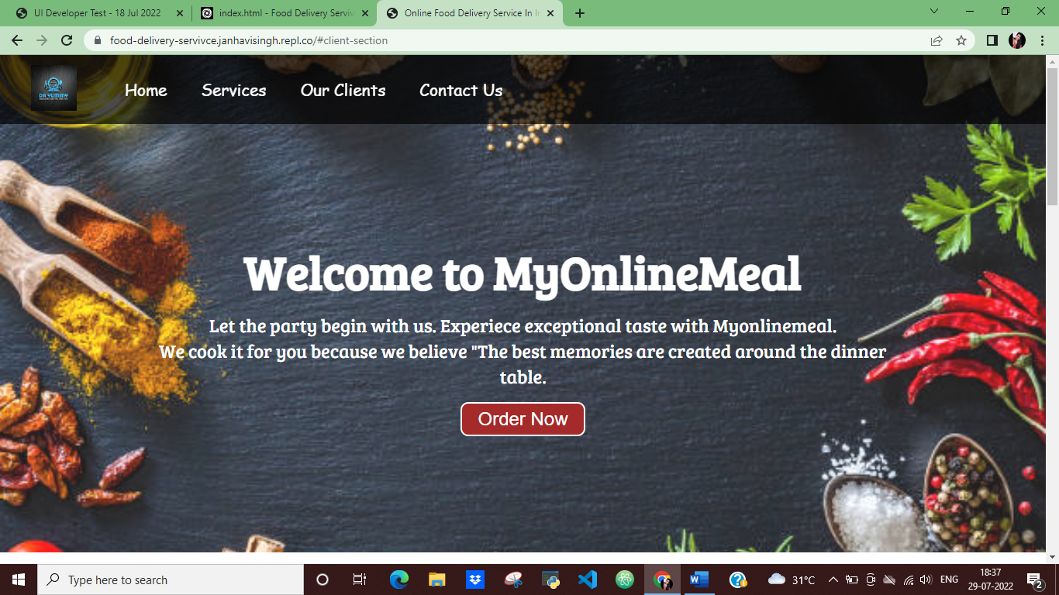

**One Plus-**

